# **Advanced Network Engineering**

This assignment comprises four questions based on the work you have undertaken in semester 2 of the module. Submit your answers after the question part and insert diagrams and cite reference material.

***Active participation in the lab sessions is required for a valid submission.***

**Submission deadline is 02/05/2019 3PM via BB.**

**Question 1** (*Based on Netmonlab1a and Netmonlab1b exercises) 25 marks*

**(a)**

1. Explain with reference to a Wireshark packet trace, what happens when you Ping a PC on the same subnet with a packet size of 2500Bytes and what the purpose of the ping –f and ping –i switch?

The purpose of of the -f switch for ping is to not set a fragment flag in the packet header. The purpose of the -i switch is to set a time to live on the packet.

(3 marks)

1. The Fluke MicroScanner cable tester gave an out of spec result of 110m for the length of the cable between a bench socket 28 and the hub room. If the incorrect NVP setting was 74% and the actual cable length is 96m, calculate the correct NVP value needed to calibrate the instrument.

NVP=V/3x10^8

(3 marks)

1. With reference to your results from part 2 (c) explain what device was most likely the performance bottleneck for Internet download speed.

(2 marks)

1. Submit a screen shot of the *CPUtest_xl* log file showing the %Processor Time and processor Queue Length counter as an Excel graph as described in lab1a Part c(ii) 7.

Explain and show your work how *Performance Console* was used to display a message on screen when processor activity exceeded a threshold value of 85%. Include screenshots of the message and application log for this event.

(4 marks)

**(b)**

1. Submit the completed Table 1 from part b 4 and comment the effect of TCP receive window size (RWIN) on throughput performance for each PHY. Estimate the min RWIN size for Gigabit Ethernet to get maximum throughput for RTT = 0.125ms.

(3 marks)

1. Report on the streaming video performance investigation over the 10BaseT Ethernet network you undertook in Part 2 (b) of lab1b. Include any relevant results to support your conclusions.

(5 marks)

1. Include a Wireshark decode to confirm that TCP checksum offloading was being done in part c (i) 6 and explain why it increased throughput performance in the benchmark tests.

(2 marks)

1. Discuss the theoretical reasons for employing Jumbo frames in the big file download scenarios and account for any unexpected results you obtained in practice.

Submit Wireshark results to show that Jumbo frames were actually being used and explain why ping <ip> -l 2500 -f doesn't cause frame fragmentation when Jumbo frames are transmitted.

(3 marks)

**Question 2** *(Based on netmonlab2 exercise) 25 marks*

**(a)**

1. State the information you obtained and OID for the Agent PC when you issued the *Get* command from the MIB browser for the *SysDescr* object.

(2 marks)

1. Submit your Wireshark SNMP packet decodesof the following:
   * Response packet carrying the *SysDescr* information highlight community name, SNMP version and UDP port number.
   * First trap generated when the SNMP agent PC service was restarted, highlighting the trap type and UDP port number.

(4 marks)

**(b)**

1. State the CLI commands used to configure the 2960 switch for operation in the public community with read only access and trap destination 192.168.1.101.

To configure the switch into for public community, access the commands: configure terminal followed by snmp-server community public are used.

(2 marks)

1. List the other management options for configuring SNMP on the Cisco 2960 switch.

(2 marks)

1. Explain how you would configure the Cisco 2960 switch so that activity on port 1 can be monitored by a monitor PC connected to port 8.

(2 marks)

**(c)**

1. Submit the NetworkView map you obtained in Part4a showing the devices discovered on you subnet.

(3 marks)

1. Show the SNMP info discovered by NetworkView about the Cisco router and list the non-SNMP discovery methods it uses to obtain information about network devices.

(2 marks)

1. State the purpose of the Cisco CDP and Microsoft LLTDP protocols. Submit Wireshark decodes showing the content of a CDP and LLTDP frame and a screenshot of the network maps.

(3 marks)

1. Write a script which can execute as a batch file on a Windows computer to discover the IP address, MAC address and NetBIOS names of all the devices on a subnet and save the results to a .txt file located on the desktop.

*Assume that you know the subnet number; that all the devices have correct addresses/subnet masks and respond to ICMP requests.*

Submit test results showing at least two discovered devices.

(5 marks)

**Question 3** *(Based on NetmonLab3 exercise) 25 marks*

**(a)**

1. Submit the table of results from part A showing the wireless networks detected with the InSSider site survey tools in signal strength order (first five entries). Define the RSSI and S/N metrics used in the table and explain what is the relationship between RSSI, S/N and data rate?

(3 marks)

1. Review the WiSPY spectrum analyser recording made during the lab session (see BB Support Resources Folder) and then identify the first time the video sender was used to jam the nwlan-5 access point. Submit a screen shot showing this period.

Suggest how video sender interference could be minimised for 802.11b/g mode and why 802.11a or 802.11ac mode might be a better choice in this case.

(3 marks)

**(b)**

1. Submit and discuss your TCP throughput results from section D when you use different security settings. Use histogram chart to compare the performance of the different scenarios.

(5 marks)

1. Submit and discuss your TCP throughput results from section D when you measure the throughput with iPerf at several distances. Use histogram chart to compare the performance of the different scenarios.

(6 marks)

**(c)**

1. With reference to the Wireshark *VoIP call Statistics* flowgraph derived from the packet capture, explain the 3 phases of a SIP phone call.

(2 marks)

1. Submit one of the decoded RTP packets from your VoIP tests highlighting the ITU G.711 codec payload and RTP, UDP and IP headers. Determine the voice payload size and show that it corresponds to the default G.711 20ms sample size in bytes. Calculate the bandwidth requirement for a G.711VoIP call over a LAN for a frame overhead of 18 bytes.

(3 marks)

1. Present the graphical results of the VoIP QoS tests made with the *Expert Analysis* feature of Observer and indicate the R-Factor and MOS score obtained. Confirm or otherwise the expectation that IEEE 802.11 supports reliable VoIP even when sharing the network with heavy data loads.

(3 marks)

**Question 4** *(Based on netmonlab4 exercise) 25 marks*

**(a)**

1. Calculate the theoretical minimum time to transfer a 100MB file over a TI WAN link using FTP and explain why it may take much longer in practice and why upgrading to a T3 service may not improve throughput very much for a long distance link.

(3 marks)

1. Submit a comparison graph showing the results you obtained for the Riverbed IT GURU WAN TCP window size optimisation simulation lab for the file transfer over a T1and T3 link for default 8KB window size and when the window size is increased to 65KB.

(3 marks)

1. Compare the simulation and emulation methods for testing this scenario and list the pros and cons of each.

(3 marks)

**(b)** The *SG TCP Optimizer* utility below allowed you to view and tune TCP settings for your client PC.

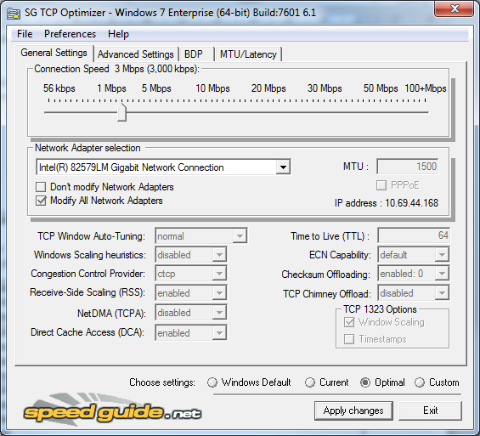

1. Distinguish between the normal and disabled TCP auto tuning levels and explain why for MSS=1460 Bytes the RWIN value of 64240Bytes may give better throughput performance than RWIN=65535 Bytes.

(3 marks)

1. Show screenshots of the *SG TCP/IP Analyzer* results for **normal** and **disabled** TCP auto tuning levels for the Downlink Global Speedtest and submit Wireshark decoded TCP SYN packets for each case with the following details highlighted:

* TCP window size
* MSS
* Scale factor
* Sack status

(5 marks)

1. State the max RWIN value achieved for the normal level download speed test and a screenshot of a TCP ACK packet advertising this value.

(2 marks)

**(c)**

1. Submit in one table the results for the real and emulated BT broadband speed tests.

(3 marks)

1. Discuss your findings for the broadband emulation and account for any major differences between the real and emulated results.

(3 marks)

Assessment Criteria

|  |  |
| --- | --- |
| 40% - 50% | Demonstrates basic knowledge largely based on the lecture notes and lab sheets  Technique lacking when performing interpretation of concepts and presenting data. |
| 50% - 60% | Demonstrates knowledge based on taught material interpretation shows good knowledge of the subject.  Appropriate techniques and tools used to obtain and analyse lab results |
| 60% - 70% | Demonstrates some knowledge beyond taught material interpretation of source demonstrates good knowledge of the subject.  Good technique used in most aspects of lab work and results analysis and presentation |
| +70% | Demonstrates knowledge beyond taught material with good interpretation of taught and sourced material.  Good technique in all aspects of lab work reporting and analysis and presentation. |